9B Unit 10 Class Website Instructions
ADV ENG 9B UNIT 10 FINAL WEBSITE PROJECT
W.6 - Use technology, including the Internet, to produce, publish, and update individual or shared writing products, taking advantage of technology's capacity to link to other information and to display information flexibly and dynamically.

- Create a Web page on the class website covering the topic of your research and writing.
- Cut and paste your writing projects on the webpage (if working as a group you must add a credit to each member’s writing)
- Create links to at least 2 sources on the webpage.
- Create a link to at least one relevant video.
- Include a slide show with at least four slides (may be text or photo).
- Add at least 3 relevant images.
- Choose interesting fonts for your text.
- Make sure your Web page is accessible in the mobile option.
- Create a file link to your list of sources.
- Please log in to: Weebly.com
Log in: p2elasgi1@gmail.com
Password: student
- Click on your assigned page number in the upper menu.
- Edit your web page only.
- Include your writing assignments, pictures, a topic headline, and links to videos or Web sites for additional information of your big questions inquiry.
- When you are finished editing, click “publish” to save your work. It will offer you a new url but only choose the existing one which ends in “weebly.com”.
Not here
Click here
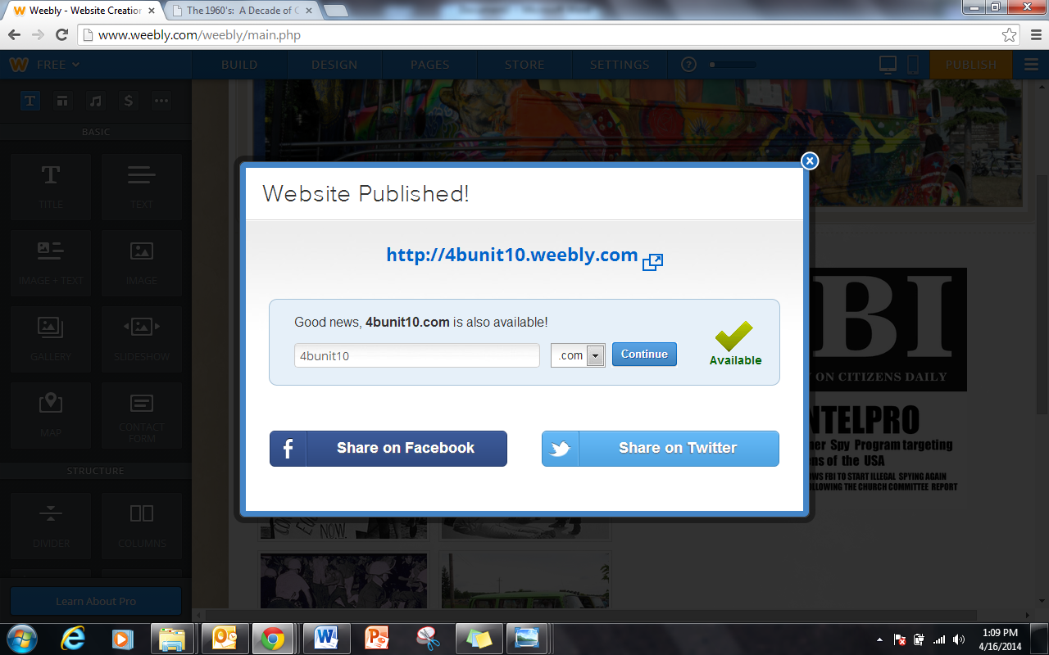

BUILDING YOUR WEB PAGE
Choose “build my site” and click on your assigned page…

Drag and drop features onto your web page…
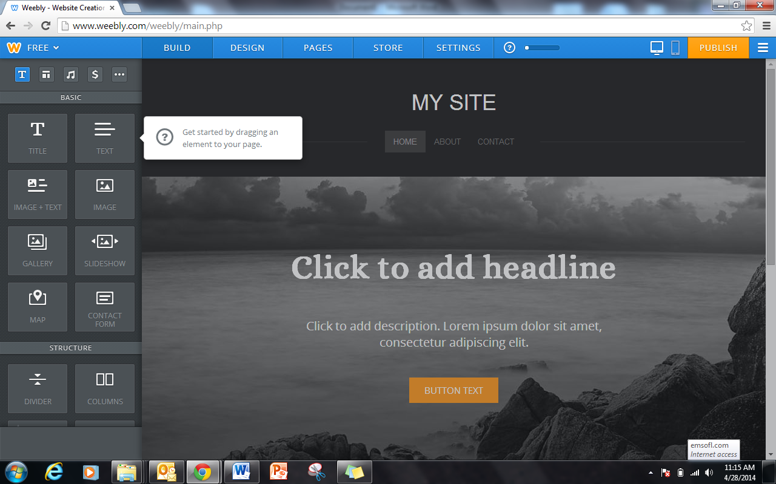

How to insert links…
Click on photo or highlight you text to activate link menu.
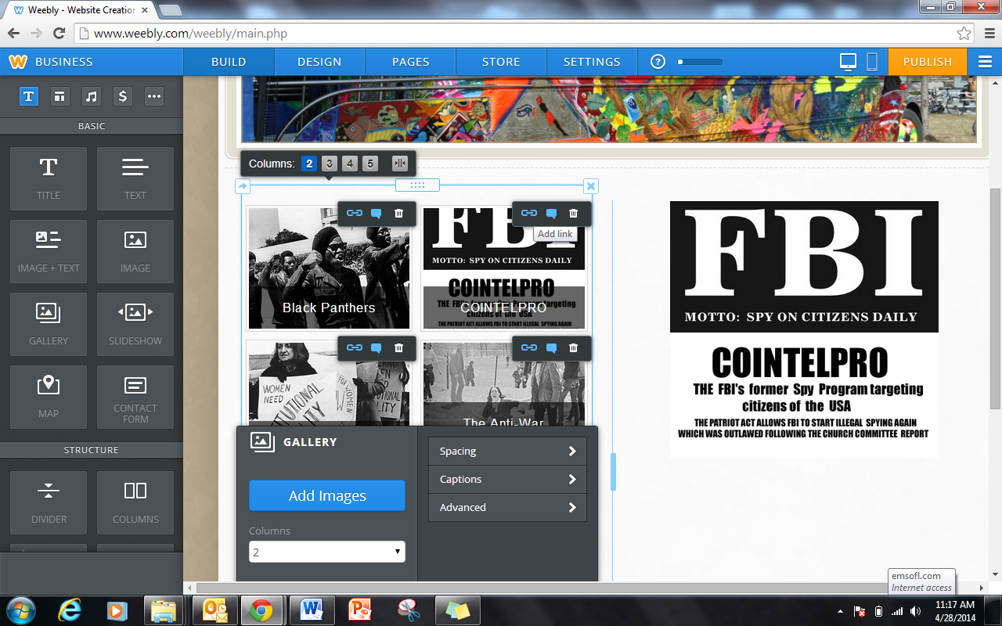

Paste a link into link template and save. Link will open when you click on picture.
