English 9B Unit 8 - Glossary worksheet
- As you conduct your research, you will encounter new words. Some of these words will have definitions specific to the topic you are researching.
- When you find these words, make note of them. Look them up.
- Then create your own glossary using Google Slides or PowerPoint.
- Your glossary should have at least five words.
- Make sure your definition is specific to the way the word is used in your research.
- Add a visual element to help you remember the new word. (See the example below.)
- Complete and turn in the attached worksheet.

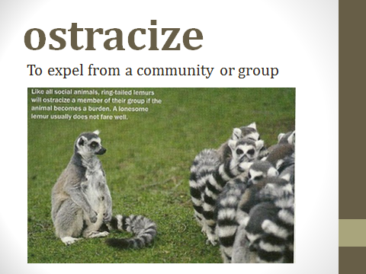

Vocabulary Worksheet for ELA 1B Unit 8 Glossary Project
Example:
Ostracize: To expel from a community or group.
After we lost the game because of my error, my teammates ostracized me on the bus ride home.
- ___________________:_____________________________________________
(WORD) (DEFINITION)
___________________________________________________________________
______________________________________________________________________________________________________________________________________
(SAMPLE SENTENCE)
- ___________________:_____________________________________________
(WORD) (DEFINITION)
___________________________________________________________________
______________________________________________________________________________________________________________________________________
(SAMPLE SENTENCE)

- ___________________:_____________________________________________
(WORD) (DEFINITION)
___________________________________________________________________
______________________________________________________________________________________________________________________________________
(SAMPLE SENTENCE)

- ___________________:_____________________________________________
(WORD) (DEFINITION)
___________________________________________________________________
______________________________________________________________________________________________________________________________________
(SAMPLE SENTENCE)

- ___________________:_____________________________________________
(WORD) (DEFINITION)
___________________________________________________________________
______________________________________________________________________________________________________________________________________
(SAMPLE SENTENCE)

