9B UNIT 7: Analytical Essay
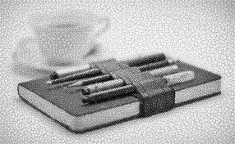
RI-2: Determine a central idea of a text and analyze its development over the course of the text, including how it emerges and is shaped and refined by specific details; provide an objective summary of the text.

SL-5: Make strategic use of digital media (e.g., textual, graphical, audio, visual, and interactive elements) in presentations to enhance understanding of findings, reasoning, and evidence and to add interest.

W-9: Draw evidence from literary or informational texts to support analysis, reflection, and research.

W-2: Write informative/explanatory texts to examine and convey complex ideas, concepts, and information clearly and accurately through the effective selection, organization, and analysis of content.

ESSAY INSTRUCTIONS
- Write a five paragraph essay analyzing the way the author chose to write their article (order of information, effectiveness of the argument, use of supporting details, attitude of the writer, audience and purpose of the article).
- Choose an article from the list on missjsenglish.weebly.com
- Evaluate (judge) and analyze (describe the parts of) the article using the rhetorical Precis
- Use the Precis as your Introductory Paragraph (just copy it exactly as you wrote it).
- In the three body paragraphs, analyze three examples of the four examples the author uses as described in your Precis.
- Use at least one quote from the article per paragraph.
- Complete the outline BEFORE you begin typing your essay.
- Complete a Research Outline Worksheet documenting your article.

