9B UNIT 7 FINAL PROJECT: Article Presentation

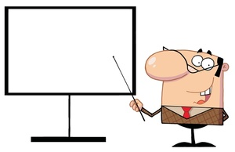

W-2: Write informative/explanatory texts to examine and convey complex ideas, concepts, and information clearly and accurately through the effective selection, organization, and analysis of content.
SL-5: Make strategic use of digital media (e.g., textual, graphical, audio, visual, and interactive elements) in presentations to enhance understanding of findings, reasoning, and evidence and to add interest.

- Create a presentation of your essay/article in your GOOGLE DRIVE (click on “new” “presentation”)
- Create a Title Slide
- Introduce your article and the MAIN IDEA
- Introduce three CLAIMS the author makes to support their THESIS (one slide per claim)
- Use at least one relevant image on each slide.
- Imbed at least one VIDEO which further supports the point the author is trying to make.
- Create a SOURCES CITED slide at the end of your presentation.
- Must be a minimum of 7 slides

