In your own words, what do you think happened?
________________________________________
________________________________________
________________________________________
________________________________________________________________________________________________________________________
Clue number 1: ________________________________________________________________________________________________________________________
________________________________________________________________________________
Clue number 2: ________________________________________________________________________________
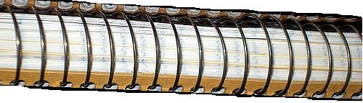

________________________________________________________________________________
________________________________________Clue number 3: ________________________________________________________________________________________________________________________________________________________________
________________________________________What do you think will happen next? ________________________________________________________________________________________________________________________________________________________________
________________________________________
________________________________________

In your own words, what do you think happened?
________________________________________
________________________________________
________________________________________
________________________________________________________________________________________________________________________
Clue number 1: ________________________________________________________________________________________________________________________
________________________________________________________________________________
Clue number 2: ________________________________________________________________________________

________________________________________________________________________________
________________________________________Clue number 3: ________________________________________________________________________________________________________________________________________________________________
________________________________________What do you think will happen next? ________________________________________________________________________________________________________________________________________________________________
________________________________________
________________________________________

Choose one case and illustrate it in the space provided

Name:
Class:
Date:

Detective Notes for:
____________________________________

by _____________________

In your own words, what do you think happened?
________________________________________
________________________________________
________________________________________
________________________________________________________________________________________________________________________
Clue number 1: ________________________________________________________________________________________________________________________
________________________________________________________________________________
Clue number 2: ________________________________________________________________________________

________________________________________________________________________________
________________________________________Clue number 3: ________________________________________________________________________________________________________________________________________________________________
________________________________________What do you think will happen next? ________________________________________________________________________________________________________________________________________________________________
________________________________________
________________________________________

