BROCHURE TEMPLATE INSTRUCTIONS

1. Click on the windows icon

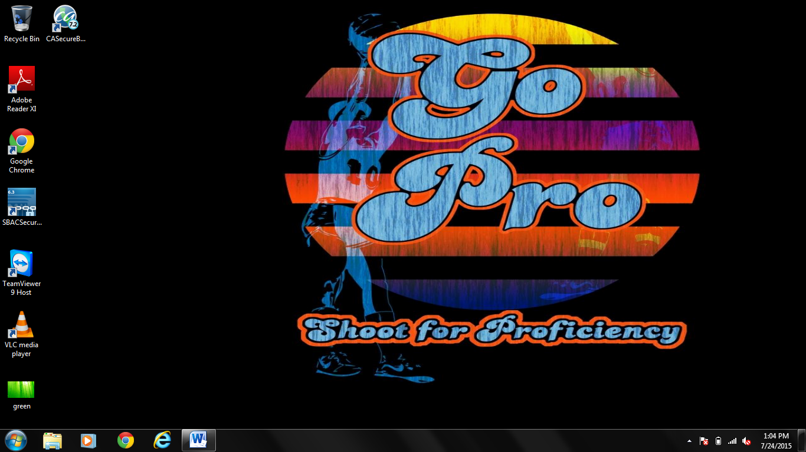

1. Click on “All Programs”

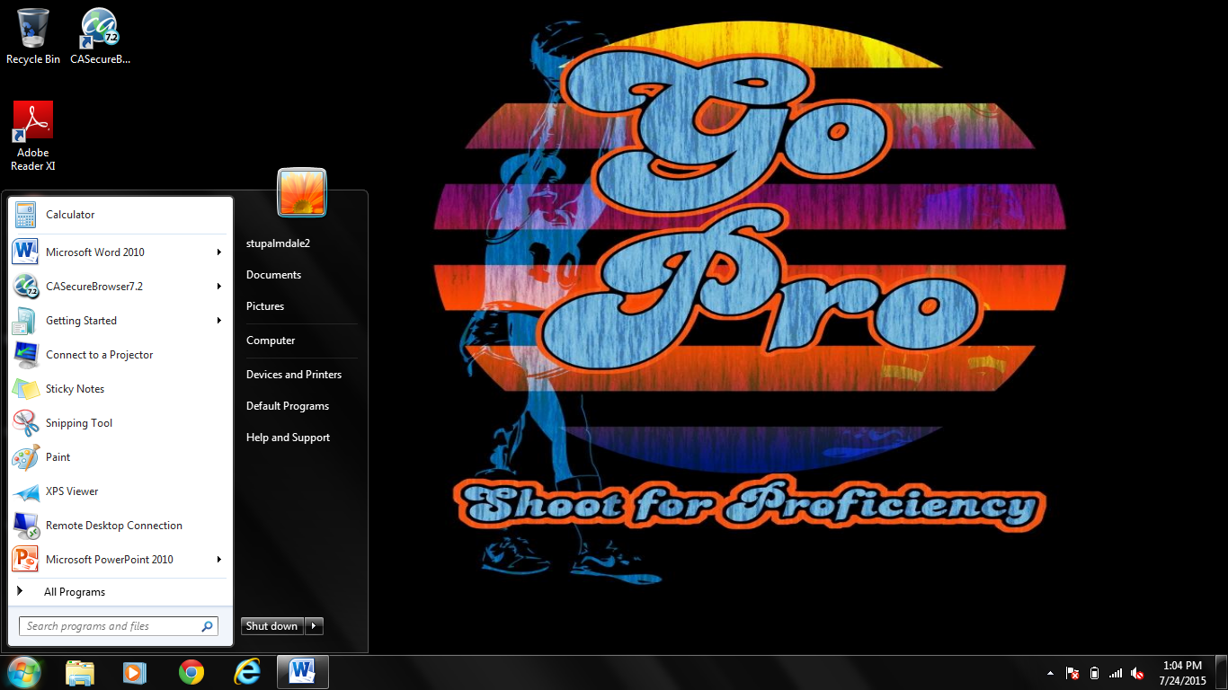

1. Click on “Microsoft Office”

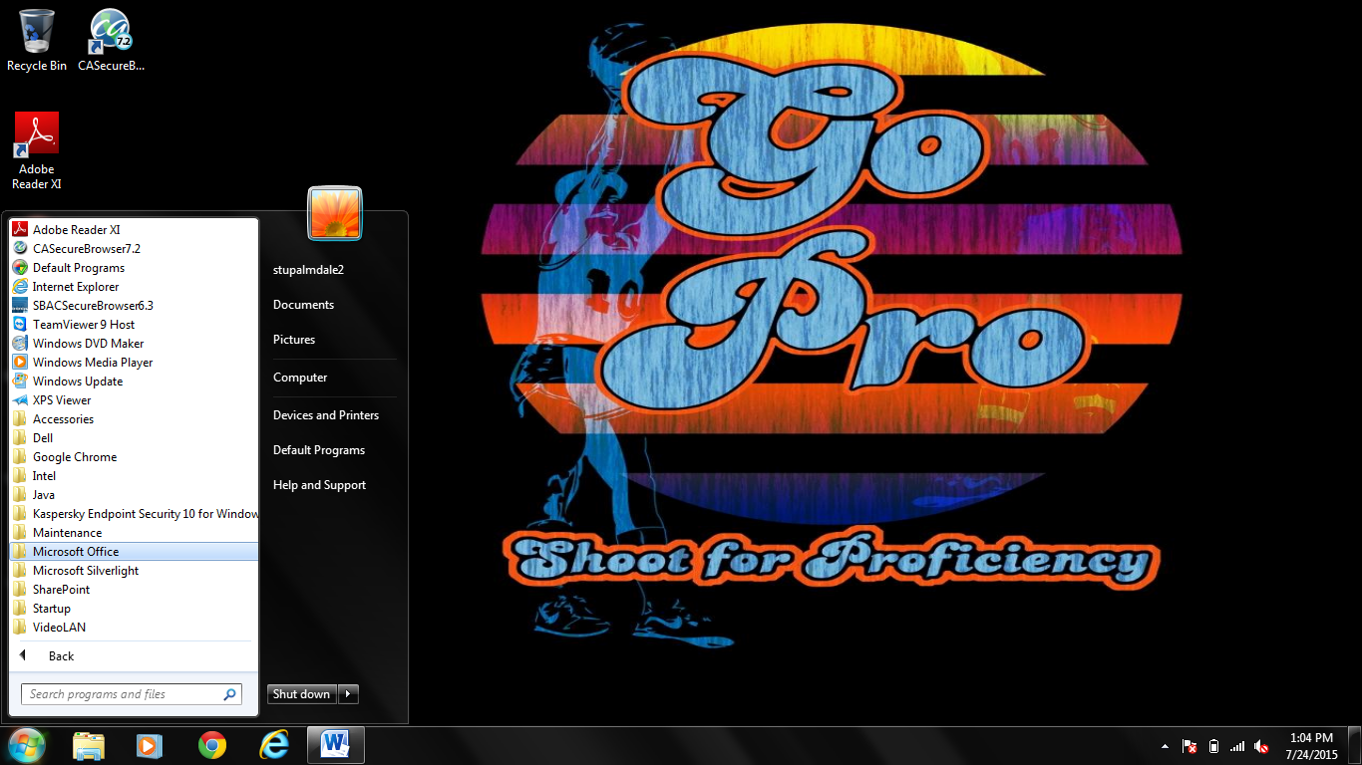

1. Click on “Microsoft Publisher”

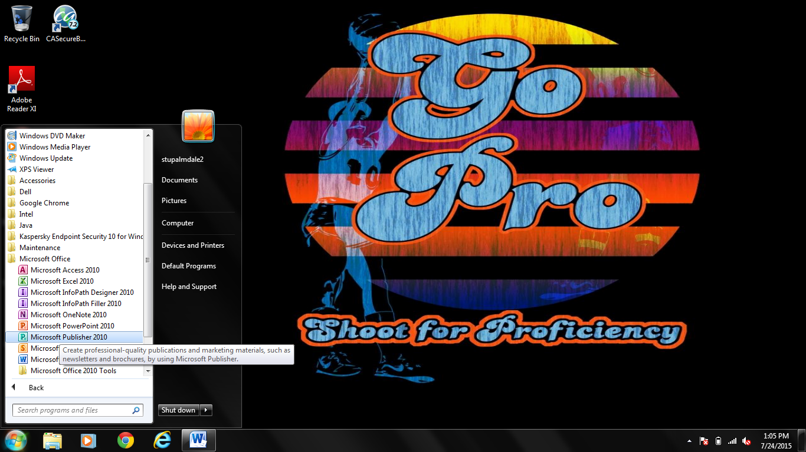

1. Click on “brochures”

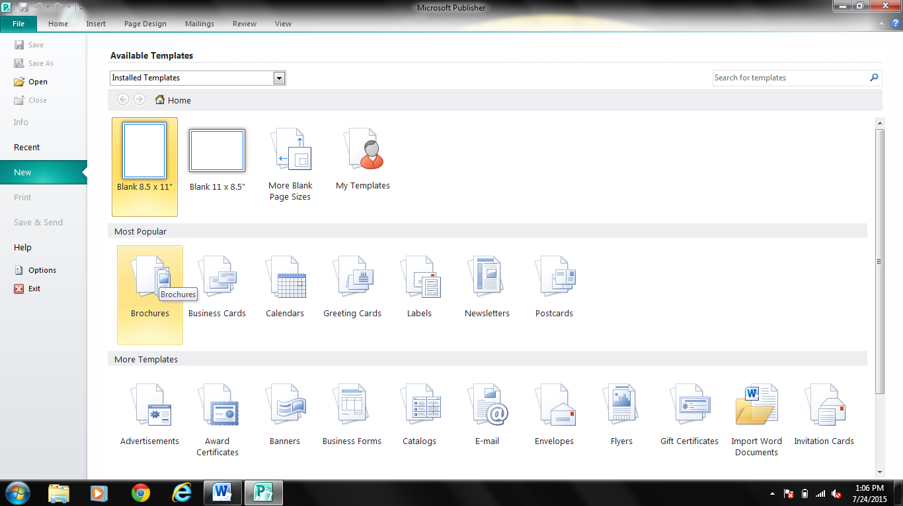

1. Choose a template

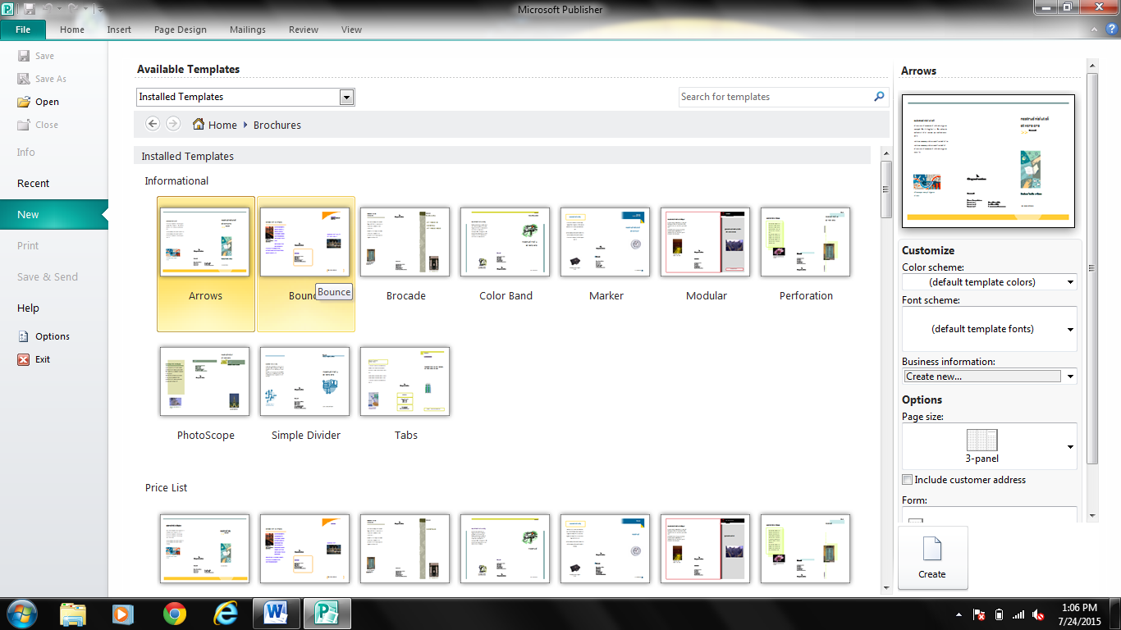

1. Replace the text and images on the template with your own.

