Uncovering Tone and Mood Guided Notes

Directions: Follow the Prezi entitled “The Power of Words” and take notes in the space below.
The prezi can be found here: http://prezi.com/ragewlyipwgi/the-power-of-words/

Mean Girls Trailer #1: List your thoughts and feelings in the box below while watching the film trailer.

Mean Girls Trailer #2: List your thoughts and feelings in the box below while watching the film trailer. How do you feel now? What changed?

Tone and Mood Defined
Tone and mood both deal with emotions centered around a piece of writing.
Mood
Tone

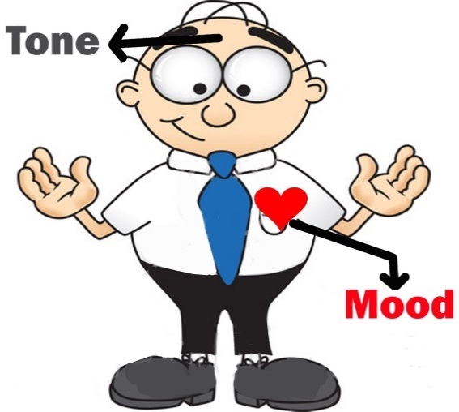

How is tone created? (Fill in the blank)

Tone refers to the of the words, images or sounds an author, artist, director, etc. uses to describe a character, event, setting, topic or other relevant subject in the work. Tone is first determined to be .

F _______________________________________________________________________________________
A _______________________________________________________________________________________
D _______________________________________________________________________________________
S _______________________________________________________________________________________

How is mood created?

MOOD refers to the specific EMOTION created by the TONE of the words, images, music, etc. the author uses in the work. While TONE is usually expressed as POSITIVE, NEGATIVE or NEUTRAL,

Toy Story Trailer #1: First, identify whether the TONE of the trailer is POSITIVE, NEGATIVE or NEUTRAL. How do you know based on FADS, music, and color.

