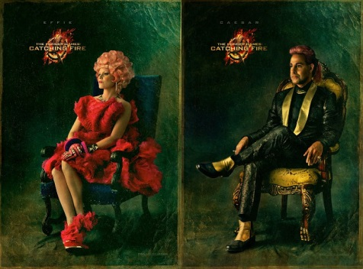
WARM-UP: THE HUNGER GAMES
Imagine you are writing an advertisement for the Hunger Games…
- What kind of audience would you cater your advertisement to (age, class, education, income bracket)?
____________________________________________________________________________________________________________________________________________________________________________________________________________________________________
- What aspects of the Hunger Games would you use as your selling point?
____________________________________________________________________________________________________________________________________________________________________________________________________________________________________
- Write a three sentence radio advertisement for the Hunger Games 2014:
__________________________________________________________________________________________________________________________________________________________________________________________________________________________________________________________________________________________________________________________________________________________________________________________________________________________________________________________________________________________________________________________________________________________________________________________

